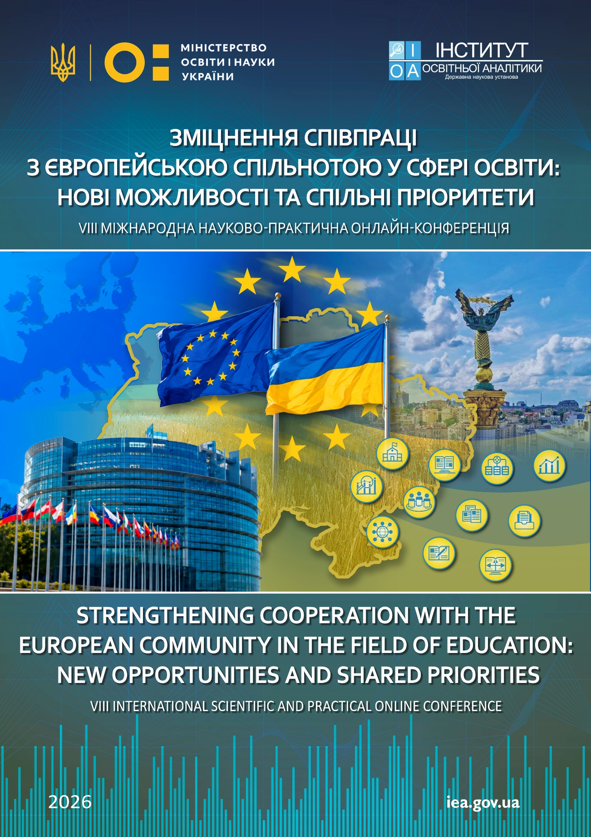
Dear Colleagues!

We are pleased to invite you to participate in the
VIІІ International Scientific and Practical Online Conference
"Strengthening Cooperation with the European Community in the Field of Education: New Opportunities and Shared Priorities",
which will take place on October 30th, 2026
at the SSI "Institute of Educational Analytics" (Kyiv, Ukraine)

The conference aims to discuss current trends and key priorities in education development, strengthen Ukraine's cooperation with the European educational community, exchange research findings and best practices in the development and implementation of educational policy, and address issues related to quality assurance, accessibility and digital transformation of education, human capital development, and international partnership in the context of the war and Ukraine's post-war recovery.
The conference is held within the framework of the EU project "Eurydice in Ukraine: Improving Access to Education" (Grant No. 101228665).
Mode of participation: online.
Working languages: Ukrainian and English.
Participation, publication of conference abstracts in electronic format, and certificates of participation are free of charge.

Conference Topics
- Section 1. Development of Ukraine's Education System in the Context of European Integration.
- Section 2. Quality, Accessibility, Inclusiveness and Resilience of Education in the Context of Contemporary Challenges.
- Section 3. Digital Transformation of Education, Artificial Intelligence and Innovative Educational Technologies.
- Section 4. Educational Analytics, Information and Analytical Support, and Education Governance.
- Section 5. Internationalisation of Education, International Partnerships and Academic Mobility.
- Section 6. Education as a Driver of Human Capital Development and Ukraine's Post-War Recovery.

Participation Guidelines
To participate in the conference, applicants are required to complete the registration form available at: https://forms.gle/ueCDmSgZfcnCUZi96 and submit their conference abstract to the Conference Organising Committee at iea.conf1@gmail.com no later than 23 October 2026. The abstract file name should include the participant's surname and initials. The subject line of the email should contain the author's surname and the section number (for example: "Shevchenko_Section 1"). Please note that registration is considered complete only after both the registration form and the abstract have been received by the Conference Organising Committee.
The Conference Abstracts Book and electronic certificates of participation will be sent to the authors' email addresses. In addition, the conference materials will be published on the website of the SSI "Institute of Educational Analytics" under the "Materials of communication events" section.
Abstracts accepted for publication in the Conference Abstracts Book may be subject to editorial revision in order to ensure consistency of formatting, improve language and style, and bring the text into line with the publication requirements, without altering the author's original content.
At the authors' request and upon the recommendation of the Conference Organising Committee, selected papers may be submitted to the editorial office of the scientific and practical journal "Educational Analytics of Ukraine" for consideration for publication in accordance with the journal's editorial policy and following the peer-review process. The journal is included in the List of Professional Scientific Publications of Ukraine (Category B; Cluster: Human Capital Development, Social Sciences and Journalism).

Abstract Submission Requirements
Abstracts may be submitted in Ukrainian or English. The abstract should not exceed five A4 pages, prepared in Microsoft Word, using Times New Roman, 14 pt, 1.5 line spacing, with 2 cm margins on all sides. References in the text should be indicated in square brackets (e.g. [1]). All statistical data, tables and figures must be supported by appropriate references to the sources used. The list of references should be arranged in the order in which the sources are cited in the text and formatted in accordance with DSTU 8302:2015.
The conference abstract should be structured as follows:
- upper right corner – section number and title (italic);
- upper left corner – author's surname and initials (bold);
- below the author's name – position, academic degree, academic title, institution (main place of work or study), city, and ORCID iD (italic);
- centre of the page – title of the abstract (UPPERCASE, bold);
- main text of the abstract;
- list of references in the order in which they are cited in the text.
Example of Abstract Formatting
Number and name of the conference section
Surname and first name
Ph.D., Professor, Head of Department (name of Institution), Kyiv, Ukraine
ORCID ID: https://orcid.org/ xxxx-xxxx-xxxx-xxxx

TITLE
Теxt [1, p.12]…
References

Submitted abstracts must comply with the principles of academic integrity. The Conference Organising Committee will screen all submitted materials for text similarity using the Turnitin plagiarism detection system.
In cases of detected plagiarism, fabrication, falsification, other violations of academic integrity, or an unacceptable level of text similarity, the Conference Organising Committee reserves the right to reject the submission without further consideration.
Generative artificial intelligence (AI) tools (including, but not limited to, ChatGPT, Gemini, Claude, and similar systems) must not be listed as authors or co-authors of conference abstracts. Their use is permitted solely as an auxiliary tool for language editing, translation, text structuring or formatting, provided that the author retains full control over the content and accepts full responsibility for the submitted work.
The Conference Organising Committee reserves the right to reject submissions that do not comply with the conference scope, formatting requirements, or the principles of academic integrity. The authors bear full responsibility for the content of their abstracts.

Conference Schedule
- 1 August 2026 - Opening of registration and abstract submission.
- 23 October 2026 - Deadline for submission of registration forms and abstracts.
- 30 October 2026 - Conference.
- December 2026 - Distribution of the Conference Abstracts Book.

For further information, please contact the Conference Organising Committee:
SSI "Institute of Educational Analytics"
Address: 5 Volodymyra Vynnychenka str., Kyiv 04053, Ukraine
Conference email: iea.conf1@gmail.com
Conference Coordinator: Nataliia Pron, tel.: +380 96 626 10 25

We look forward to your participation in the conference!

