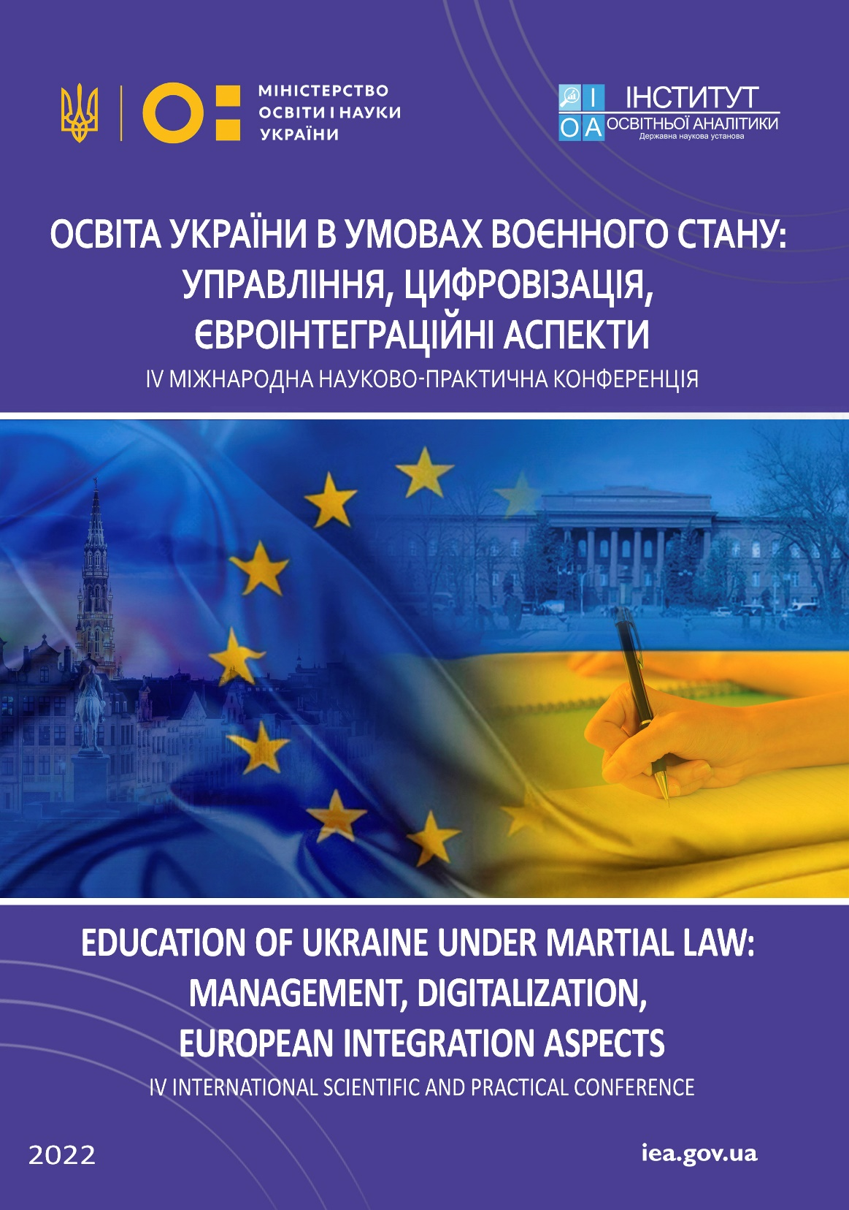

Dear Colleagues!

We have a pleasure to invite you to participate in the
ІV International Scientific and Practical Conference
«EDUCATION OF UKRAINE UNDER MARTIAL LAW: MANAGEMENT, DIGITALIZATION, EUROPEAN INTEGRATION ASPECTS»,
held on October 25th, 2022
at the SSI «Institute of Educational Analytics» (Kyiv, Ukraine)

The main purpose of the conference is a scientific discussion with the view to solving the relevant problems of the Ukrainian education and science that arose due to the implementation of the martial law in Ukraine as a result of the full-scale, unprovoked armed aggression of the Russian Federation against Ukraine, a discussion of current issues and priorities to ensure the functioning of Ukrainian education system in the post-war period, an exchange of knowledge and practices regarding the development of promising digital technologies and information systems to facilitate scientific and educational activities amidst the war, the strengthening of scientific cooperation and the search for the international partners to implement joint scientific and research projects.
The form of participation in the conference is remote (distant).
Languages: Ukrainian, English
Electronic Collection of abstracts and a Conference participation certificate are free of charge.

Conference Sections:
- Section 1. Education management issues during the martial law
- Section 2. Financial and economic aspects of education under the martial law
- Section 3. Development of information and educational technologies under the martial law
- Section 4. Psychological support for the education process participants
- Section 5. Integration of forcibly displaced Ukrainian children and teachers into the national education systems of the EU countries
- Section 6. International support of the Ukrainian researchers and educators during the martial law
- Section 7. Eurointegration prospects of the education development during the post-war period

Regulations for participation in the conference:

To participate in the conference, it is necessary to send abstracts in the electronic form to the email address of the Conference Organizing Committee (iea.conf1@gmail.com) by October 10, 2022, as well as to fill in the participant’s application form. The file names must be signed according to the surname and initials of the conference participant (e. g., Surname, initials_abstracts, Surname, initials_application). In the subject of the letter, it is necessary to indicate the author's name and section number (for example, "Surname_section 1").
The Collection of abstracts and certificates in electronic form will be sent to the authors’ email addresses. The conference materials will also be available on the website of the SSI «Institute of Educational Analytics» under the heading «Materials of communication events». Separate reports on the willingness of the authors may be printed after completion in the journal «Educational Analytics of Ukraine».
APPLICATION FORM
ІV International Scientific and Practical Conference
«EDUCATION OF UKRAINE UNDER MARTIAL LAW: MANAGEMENT, DIGITALIZATION, EUROPEAN INTEGRATION ASPECTS»,
October 25th, 2022
Kyiv, Ukraine

1 | Surname, First name
2 | Academic degree
3 | Academic status
4 | Position
5 | The official name of the institution where the author works/studies
6 | City
7 | Country
8 | Еmail
9 | ORCID ID (https://orcid.org/) | https://orcid.org/xxxx-xxxx-xxxx-xxxx
10 | Тelephone
11 | Name of the conference section
12 | Title abstracts
13 | Indicate whether you would like to deliver a presentation on abstracts at the plenary session of the Сonference
Requirements for abstracts:
The manuscripts are submitted in Ukrainian or English. The abstracts should not exceed 5 printed pages in A4 format, typed in MS Word, font “Times New Roman”, font size – 14, line spacing – 1,5, all margins – 2 cm each. In the text, all statistics, tables, figures should be supported by references to the numbers of sources from the bibliography, indicating the pages to which the author refers. References in the text are made in square brackets [1], all statistics, tables, figures must be supported by references to sources. The list of used sources is given in the order of reference in the text.
Placement of materials: in the upper right corner – the name of the conference section (font – italics); in the upper left corner – the author’s surname and name (font – bold); job position, the name of the institution where the author works/studies (font – italics), ORCID ID; in the center – the title of the abstract (capital letters, font – bold); thesis text; references used in the order of mention in the text.

Example of abstracts design:
Number and name of the conference section
Surname and first name
Ph.D., Professor, Head of Department (name of Institution), Kyiv, Ukraine
ORCID ID: https://orcid.org/ xxxx-xxxx-xxxx-xxxx

TITLE
Теxt [1, p.12]…
References
The Conference Organizing Committee reserves the right to reject materials that do not meet the requirements or the subject of the conference. Abstracts are not further edited; the author is responsible for the content and design of materials.

Conference calendar:
- August, 25 – reception of materials starts
- October, 10 – deadline for submissions
- October, 25 – conference work and distribution of the Collection of abstracts

For additional information please contact the Conference Organizing Committee:
SSI «Institute of Educational Analytics»
Address: 5 Volodymyra Vynnychenka str., Kyiv, Ukraine
Conference email: iea.conf1@gmail.com
Conference coordinators’ telephone: (096) 626-10-25 (Natalia Pron)

We wish all the participants success and hope for cooperation!
We are strong! We are Ukraine!

